13EXP: Beamforming & Beamsteering Simulation
a) To implement analog, digital, and hybrid beamforming for a uniform linear antenna
array to study different beamforming techniques.
b) To visualize radiation patterns and beam direction to analyze how the array focuses
energy toward desired angles.
c) To evaluate beamforming gain and interference reduction to assess the effectiveness
of each beamforming method in improving signal quality.

AIM:
To implement analog, digital, and hybrid beamforming for a Uniform Linear Array (ULA) using MATLAB, visualize radiation patterns, and evaluate beamforming gain and interference suppression.

THEORY:
Beamforming focuses energy in a chosen direction by adjusting antenna weights.
Types of beamforming:
- Analog: Phase-only control using RF phase shifters.
- Digital: Full complex weights applied in baseband (MRC, MVDR).
- Hybrid: Combination of analog phase shifters and few digital RF chains (used in 5G mmWave).
Array factor:Beamforming improves gain, reduces interference, and enhances SINR.

PROCEDURE:
- Set frequency, wavelength, number of antenna elements, spacing, and angle grid in MATLAB.
- Analog beamformer: phase-only weights.
- Digital beamformers: MRC and MVDR formulas.
- Hybrid beamformer: RF matrix + digital baseband weights.
- In MATLAB, plot AF (in dB) for each method to observe beam direction and side-lobes.
- Gain at desired angle
- Gain at interferer angle
- SINR for each beamforming method
- Compare analog vs digital vs hybrid beamforming to identify which gives best gain and interference suppression.

PROGRAM:
% beamforming_sim.m
% Single-file simulation: analog, digital, and hybrid beamforming for a ULA.
% Plots radiation patterns and computes beamforming gain & interference reduction.
% Author: ChatGPT (GPT-5.1)

clear; close all; clc;

%% ========== Simulation Parameters ==========
fc = 3e9; % carrier frequency (Hz)
c = 3e8; % speed of light (m/s)
lambda = c/fc; % wavelength (m)
N = 16; % number of antenna elements (ULA)
d = lambda/2; % element spacing
angles = -90:0.1:90; % angle grid
k = 2*pi/lambda;

% Desired & interferer angles
theta_des = 20;
theta_int = -30;

% Signal / noise parameters
Ptx = 1;
sigma2 = 1e-3;
Pint = 1;

% Hybrid beamforming
NRF = 3;
maxOMPiter = NRF;

% Convert to radians
angles_rad = deg2rad(angles);
theta_des_rad = deg2rad(theta_des);
theta_int_rad = deg2rad(theta_int);

%% ========== Helper functions ==========
steeringVector = @(N, d, k, theta) exp(1j * k * d * (0:(N-1)).' * sin(theta));

arrayFactor = @(w, N, d, k, angles_rad) ...
arrayfun(@(th) w(:)' * steeringVector(N, d, k, th), angles_rad);

normc = @(x) x / norm(x);

%% ========== Steering vectors ==========
a_des = steeringVector(N, d, k, theta_des_rad);
a_int = steeringVector(N, d, k, theta_int_rad);

%% ========== DIGITAL BEAMFORMING ==========
% 1) MRC (conjugate)
w_dig_mrc = conj(a_des);
w_dig_mrc = w_dig_mrc / norm(w_dig_mrc);

% 2) MVDR
R_int = Pint*(a_int*a_int') + sigma2*eye(N);
w_dig_mvdr = (R_int \ a_des) / (a_des' * (R_int \ a_des));
w_dig_mvdr = w_dig_mvdr / norm(w_dig_mvdr);

%% ========== ANALOG (PHASE-ONLY) BEAMFORMING ==========
w_analog = exp(-1j * angle(a_des));
w_analog = w_analog / norm(w_analog);

%% ========== HYBRID BEAMFORMING (OMP-BASED) ==========
w_opt = conj(a_des);
w_opt = w_opt / norm(w_opt);

% dictionary
Ngrid = 181;
dict_angles = linspace(-pi/2, pi/2, Ngrid);
A_dict = zeros(N, Ngrid);
for ii = 1:Ngrid
A_dict(:,ii) = steeringVector(N,d,k,dict_angles(ii));
end
for ii = 1:Ngrid
A_dict(:,ii) = A_dict(:,ii)/norm(A_dict(:,ii));
end

% OMP
residual = w_opt;
selected_idx = [];
F_RF = zeros(N, NRF);

for iter = 1:maxOMPiter
projections = abs(A_dict' * residual);
[~, idx] = max(projections);
selected_idx = [selected_idx idx];
F_RF(:,iter) = exp(1j * angle(A_dict(:,idx)));

Fsub = F_RF(:,1:iter);
fBB = pinv(Fsub) * w_opt;
residual = w_opt - Fsub * fBB;
end

% Final hybrid
fBB = pinv(F_RF) * w_opt;
W_hybrid = F_RF*fBB;
W_hybrid = W_hybrid / norm(W_hybrid);

%% ========== Array Factors ==========
AF_analog = arrayFactor(w_analog, N, d, k, angles_rad).';
AF_dig_mrc = arrayFactor(w_dig_mrc, N, d, k, angles_rad).';
AF_dig_mvdr = arrayFactor(w_dig_mvdr, N, d, k, angles_rad).';
AF_hybrid = arrayFactor(W_hybrid, N, d, k, angles_rad).';

to_dB = @(x) 20*log10(abs(x)/max(abs(x))+1e-12);

AF_analog_dB = to_dB(AF_analog);
AF_dig_mrc_dB = to_dB(AF_dig_mrc);
AF_dig_mvdr_dB = to_dB(AF_dig_mvdr);
AF_hybrid_dB = to_dB(AF_hybrid);

%% ========== Plot Radiation Patterns ==========
figure('Name','Radiation Patterns','Position',[100 100 1100 600]);
subplot(2,2,1); plot(angles,AF_analog_dB); grid on; ylim([-60 0]);
title('Analog Beamforming'); xlabel('Angle (deg)'); ylabel('Array Pattern (dB)')

subplot(2,2,2); plot(angles,AF_dig_mrc_dB); grid on; ylim([-60 0]);
title('Digital MRC'); xlabel('Angle (deg)'); ylabel('Array Pattern (dB)')

subplot(2,2,3); plot(angles,AF_dig_mvdr_dB); grid on; ylim([-60 0]);
title('Digital MVDR'); xlabel('Angle (deg)'); ylabel('Array Pattern (dB)')

subplot(2,2,4); plot(angles,AF_hybrid_dB); grid on; ylim([-60 0]);
title('Hybrid Beamforming'); xlabel('Angle (deg)'); ylabel('Array Pattern (dB)')

figure('Name','Comparison','Position',[150 150 800 420]);
plot(angles,AF_analog_dB,'LineWidth',1.2); hold on;
plot(angles,AF_dig_mrc_dB,'LineWidth',1.2);
plot(angles,AF_dig_mvdr_dB,'LineWidth',1.2);
plot(angles,AF_hybrid_dB,'LineWidth',1.2);
grid on; xlim([-90 90]);
xlabel('Angle (deg)'); ylabel('dB');
legend('Analog','Digital-MRC','Digital-MVDR','Hybrid','Location','southwest');
title('Comparison of Beamforming Techniques');

%% ========== Beamforming Gain & Interference ==========
resp = @(w,theta) w' * steeringVector(N,d,k,theta);

% FIXED field names (no hyphens)
methods = {'Analog','Digital_MRC','Digital_MVDR','Hybrid'};
weights = {w_analog, w_dig_mrc, w_dig_mvdr, W_hybrid};

results = struct();

for i = 1:length(methods)
w = weights{i};
g_des = abs(resp(w,theta_des_rad))^2;
g_int = abs(resp(w,theta_int_rad))^2;

Psig = Ptx*g_des;
Pint_eff = Pint*g_int;
Pnoise = sigma2*(norm(w)^2);
SINR = Psig/(Pint_eff+Pnoise);

results.(methods{i}).g_des = g_des;
results.(methods{i}).g_int = g_int;
results.(methods{i}).Psig = Psig;
results.(methods{i}).Pint_eff = Pint_eff;
results.(methods{i}).Pnoise = Pnoise;
results.(methods{i}).SINR = SINR;
end

%% ========== Display Results ==========
T = table(methods', ...
cellfun(@(m) results.(m).g_des, methods)', ...
cellfun(@(m) results.(m).g_int, methods)', ...
cellfun(@(m) results.(m).SINR, methods)', ...
'VariableNames', {'Method','ArrayGain_Desired','ArrayGain_Interferer','SINR_Linear'});

disp('--- Beamforming Performance ---');
disp(T);

fprintf("\nSINR (dB):\n");
for i=1:length(methods)
fprintf("%s : %.2f dB\n", methods{i}, 10*log10(results.(methods{i}).SINR));
end

PSEUDO CODE:
clc; clear; close all;
%% PARAMETERS
fc = 28e9; % 28 GHz
c = 3e8;
lambda = c/fc;
N = 8; % Number of antennas
d = lambda/2; % Element spacing
angles = -90:0.1:90; % Scan grid (deg)
ang_rad = deg2rad(angles);
desired_ang = 20; % Desired user
interf_ang = -40; % Interference
desired_rad = deg2rad(desired_ang);
interf_rad = deg2rad(interf_ang);
noise = 0.01;
Pint = 1;
Ptx = 1;
%% FUNCTION: Steering vector
steer = @(theta) exp(1j*2*pi*(0:N-1)'*d*sin(theta)/lambda);
a_des = steer(desired_rad);
a_int = steer(interf_rad);
%% DIGITAL BEAMFORMING
% ----- MRC -----
w_MRC = conj(a_des);
w_MRC = w_MRC / norm(w_MRC);
% ----- MVDR -----
R = Pint*(a_int*a_int') + noise*eye(N);
w_MVDR = (R \ a_des) / (a_des' * (R \ a_des));
w_MVDR = w_MVDR / norm(w_MVDR);
%% ANALOG BEAMFORMING (phase shifters)
w_analog = exp(1j * angle(a_des));
w_analog = w_analog / norm(w_analog);
%% HYBRID BEAMFORMING (simple RF + BB)
NRF = 2;
F_RF = zeros(N, NRF);
theta_dict = deg2rad(-90:1:90);
A_dict = zeros(N, length(theta_dict));
for i = 1:length(theta_dict)
A_dict(:, i) = steer(theta_dict(i));
end
residual = a_des;
for k = 1:NRF
corr = abs(A_dict' * residual);
[~, idx] = max(corr);
F_RF(:, k) = exp(1j * angle(A_dict(:, idx))); % phase-only RF
% baseband weights using least squares
fBB = pinv(F_RF) * a_des;
hybrid = F_RF * fBB;
residual = a_des - hybrid;
end
W_hybrid = F_RF * fBB;
W_hybrid = W_hybrid / norm(W_hybrid);
%% ARRAY FACTOR FOR ALL
AF_analog = zeros(size(ang_rad));
AF_MRC = zeros(size(ang_rad));
AF_MVDR = zeros(size(ang_rad));
AF_hybrid = zeros(size(ang_rad));
for i = 1:length(ang_rad)
a_theta = steer(ang_rad(i))
AF_analog(i) = abs(w_analog' * a_theta);
AF_MRC(i) = abs(w_MRC' * a_theta);
AF_MVDR(i) = abs(w_MVDR' * a_theta);
AF_hybrid(i) = abs(W_hybrid' * a_theta);
end
AF_analog = 20*log10(AF_analog/max(AF_analog));
AF_MRC = 20*log10(AF_MRC/max(AF_MRC));
AF_MVDR = 20*log10(AF_MVDR/max(AF_MVDR));
AF_hybrid = 20*log10(AF_hybrid/max(AF_hybrid));
%% PLOTS
figure;
plot(angles,AF_analog,'LineWidth',2); hold on;
plot(angles,AF_MRC,'LineWidth',2);
plot(angles,AF_MVDR,'LineWidth',2);
plot(angles,AF_hybrid,'LineWidth',2);
grid on; xlabel('Angle (deg)'); ylabel('Array Factor (dB)');
title('Beamforming Patterns');
legend('Analog','MRC','MVDR','Hybrid');
%% GAIN & SINR
methods = {'Analog','MRC','MVDR','Hybrid'};
weights = {w_analog, w_MRC, w_MVDR, W_hybrid};
disp('--- Beamforming Performance ---');
for i = 1:4
w = weights{i};
g_des = abs(w' * a_des)^2;
g_int = abs(w' * a_int)^2;
Psig = Ptx * g_des;
Pint_eff = Pint * g_int;
Pnoise = noise * norm(w)^2;
SINR = Psig / (Pint_eff + Pnoise);
fprintf("%s: Gain(des)=%.2f Gain(int)=%.2f SINR(dB)=%.2f\n", ...
methods{i}, g_des, g_int, 10*log10(SINR));
end
OUTPUT: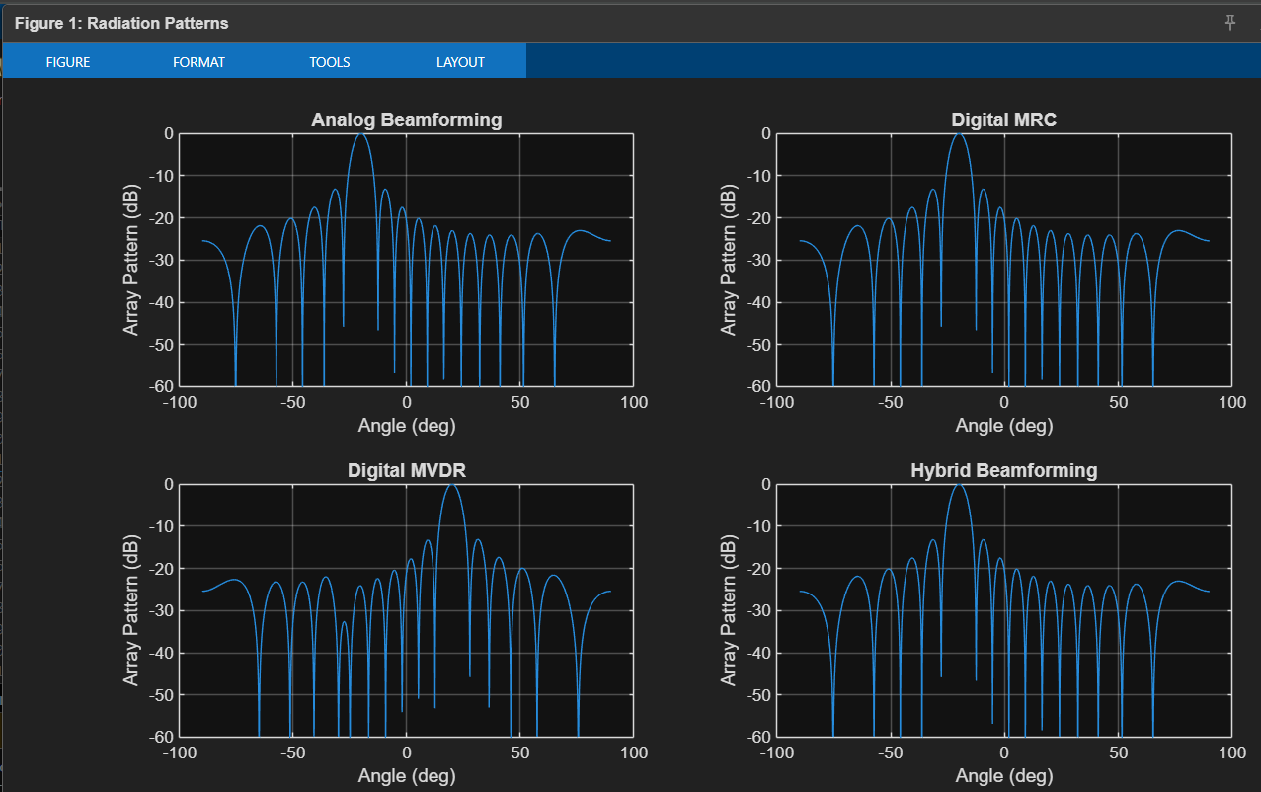

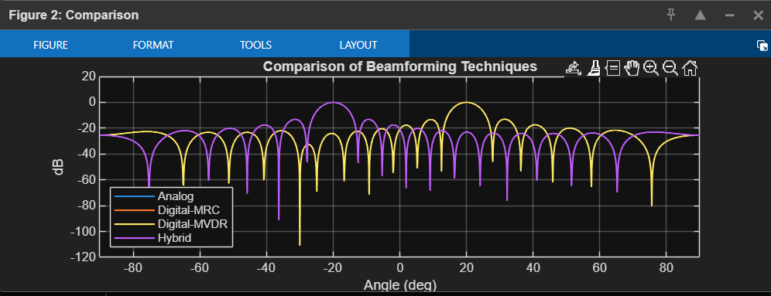

OUTPUT CONSOLE:
Beamforming Performance ---
Method ArrayGain_Desired ArrayGain_Interferer SINR_Linear
________________ _________________ ____________________ ___________
{'Analog' } 0.080218 0.563 0.14223
{'Digital_MRC' } 0.080218 0.563 0.14223
{'Digital_MVDR'} 15.964 1.4149e-10 15964
{'Hybrid' } 0.080218 0.563 0.14223
SINR (dB):
Analog : -8.47 dB
Digital_MRC : -8.47 dB
Digital_MVDR : 42.03 dB
Hybrid : -8.47 dB

CONCLUSION:
Beamforming techniques successfully steer the beam toward the desired direction and reduce interference. Digital and hybrid beamforming provide higher gain and better interference suppression compared to analog beamforming, making them more suitable for advanced wireless systems.

